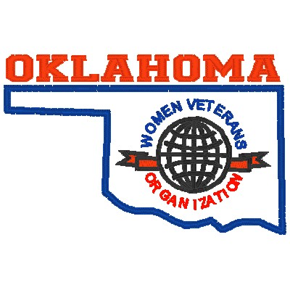

Oklahoma Women Veterans Organization (OKWVO)

Lawton/Fort Sill Chapter
-
0116

P
.
O
.

Box 2342
,
Lawton,
O
K 73502

womenvetslawtonftsill16@gmail.com

Not
-
For
-
Profit 501(
c)
(19)
War Veterans
Organization

We are a non-profit 501(c) (19) war veteran organization of women veterans who have served or are still serving on Active Duty, Reserve or the Guard in any Branch of Service of the United States of America. To become a member you must have served at least 90 days with an honorable discharge; proof of service is required. For more information on meeting dates and Chapters in your area visit our web site at www.okwvo.org. You do not need to be a resident in Oklahoma to become a member.
Please Check _____RENEWAL _____NEW MEMBER
Name:________________________________________________________________ Today’s Date:____________
Address:________________________________________________________________________________________
Home Phone: ___________________________________ Cell Phone:_____________________________________ E-mail: _______________________________________________________ DOB (day/month):_________________
Emergency Contact - Name/Phone/Relationship:______________________________________________________
Branch of Service:_________________________ Dates of Service:_____________________ (Proof of Service Requiredcopy of DD-214)
Member of Women In Military Service For America (WIMSA)? Yes / No (circle one) (if No, to register, please go to https://www.womensmemorial.org help keep our history going.
Veteran / Guard / Reserve:
___ 1 year = $10
___ 2 years = $18
___ 3 years = $28 ___ 75+ years = Free Active Duty:
___ E-4 and below = Free
___ E-5 and above = $5 per year
___ College Senior in Oklahoma ROTC Program = Free (proof of enrollment is required)
Payment Method: Cash, check or money order only (payable to Oklahoma Women Veterans Organization; do not mail cash)
Return completed application with payment to: Oklahoma Women Veterans Organization-Lawton/Fort Sill-0116,
PO Box 2342, Lawton, OK 73502, (405) 316-8443.
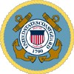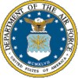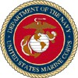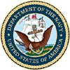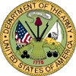

U. Lisa Williams, President Kathryn Mays, Vice President Silvia Qualls, Secretary Belreat Hodge-Pleass, Treasurer
Revised Dec 6, 2025

